COMPUTER ENGINEERING DEPARTMENT

SUBMISSION REPORT
SUB: Machine Learning

COURSE: T.E. Year: 2020-2021 Semester: VI
DEPT: Computer Engineering
SUBJECT CODE: CSDLO6021 SUBMISSION DATE: 18/05/2021
==========================================================================================

Name: Amey Thakur | Roll No.: 50
Class: TE Comps B | ID: TU3F1819127

INDEX

Sr.No. | Particulars | Submitted/Not Submitted or Enter Marks received
Assignments
1 | Assignment No. 1 | 9/10
2 | Assignment No. 2 | 9/10
3 | Assignment No. 3 | 9/10
Quizzes
4 | ML Quiz 1 | 10/10
5 | ML Quiz 2 | 10/10
6 | ML Quiz 3 | 10/10
7 | ML Quiz 4 | 10/10
8 | ML Quiz 5 | 10/10
9 | ML Quiz 6 | 10/10
IAT
10 | IAT-1 | 17/20
11 | IAT-2 | Submitted
Exit Survey
12 | Course Exit Survey | Submitted
Signature:
Assignments

Machine Learning Assignment 1
Marks: (9/10)
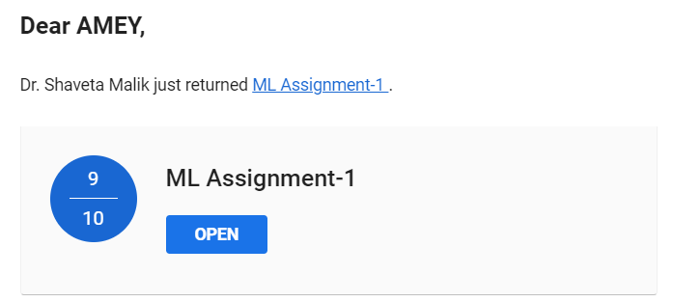

Machine Learning Assignment 2
Marks: (9/10)
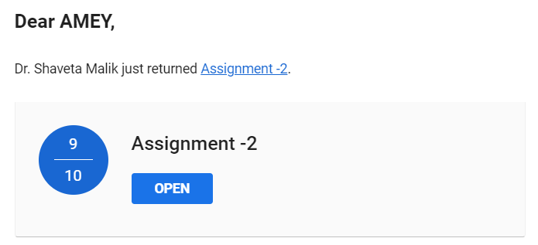

Machine Learning Assignment 3
Marks: (9/10)
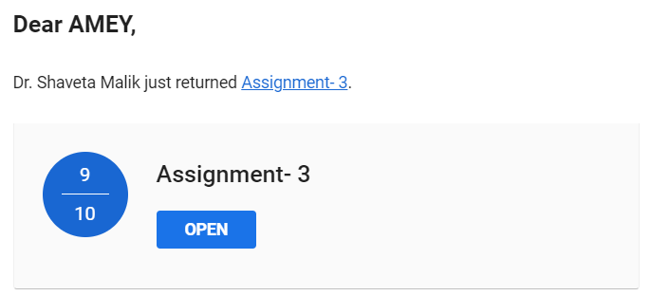

Quizzes

Machine Learning Quiz 1
Marks: (10/10)
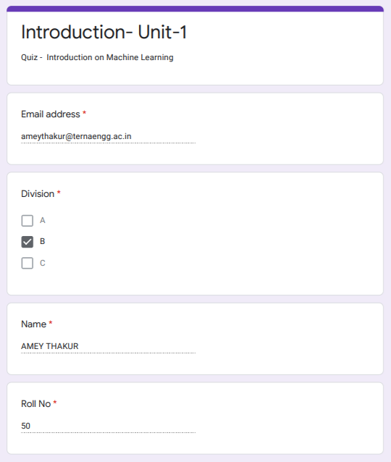

Machine Learning Quiz 2
Marks: (10/10)
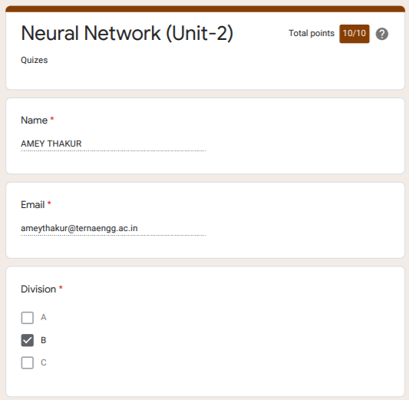

Machine Learning Quiz 3
Marks: (10/10)
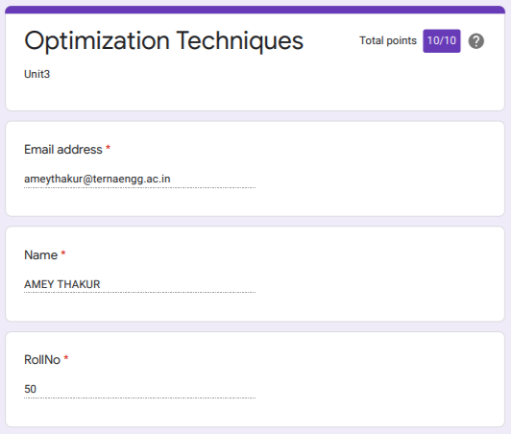

Machine Learning Quiz 4
Marks: (10/10)
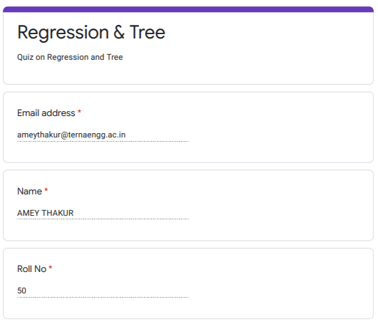

Machine Learning Quiz 5
Marks: (10/10)
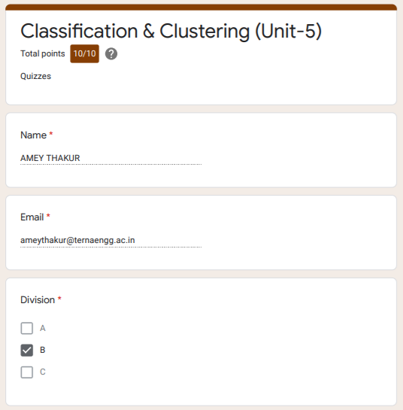

Machine Learning Quiz 6
Marks: (10/10)

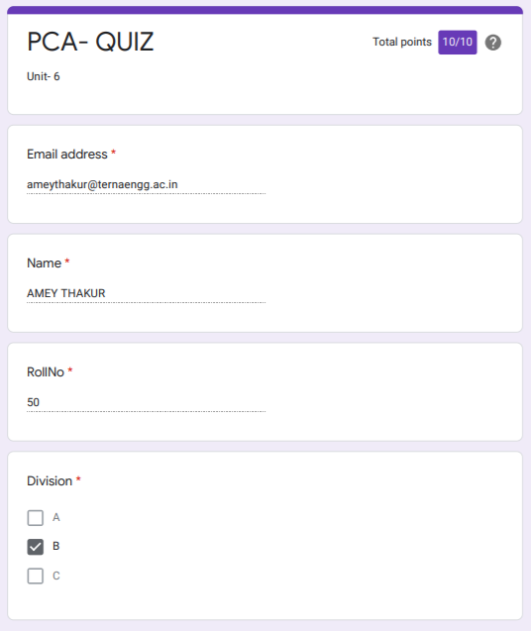

IAT

Machine Learning IAT 1
Marks: (17/20)

IAT 1 Descriptive Answer Sheet
(First page attached)
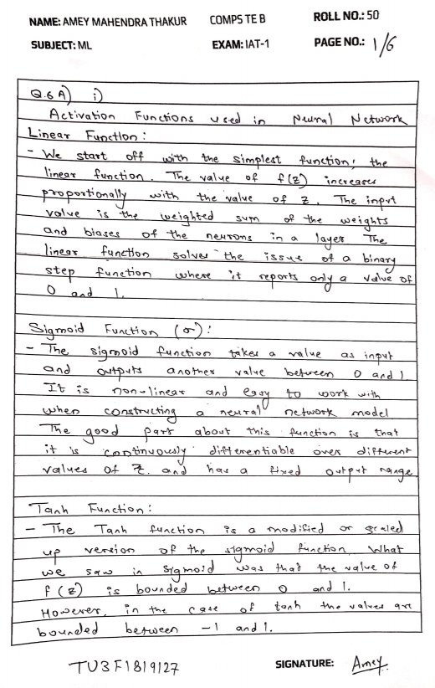
Machine Learning IAT 2
Marks: Not Received

IAT 2 Descriptive Answer Sheet
(First page attached)

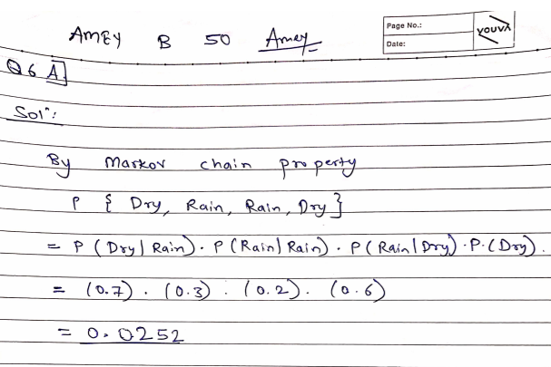

Exit Survey

Machine Learning Course Exit survey
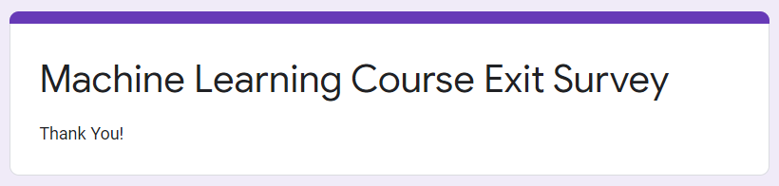

Google Classroom Submission Report

